**(EEL2020)** **DIGITAL DESIGN LAB5 REPORT**

KARTIK CHOUDHARY B20CS025

**Work** 1. Write a program to implement a Barrel Shifter

*Test bench*

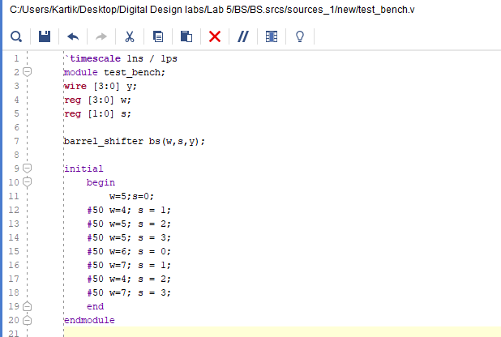

*Verilog Code*

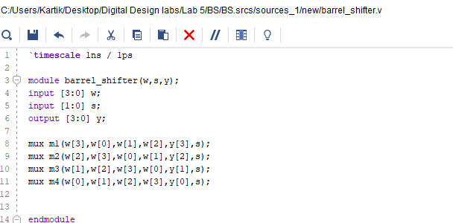

*Waveform*

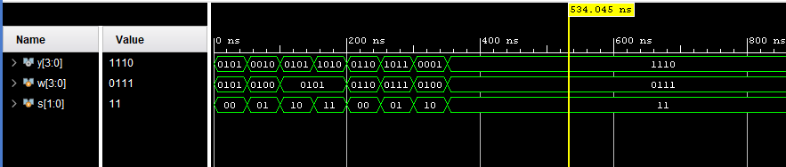

**Work 2: Write a Program to implement a 32 bit ALU.**

*Test Bench*

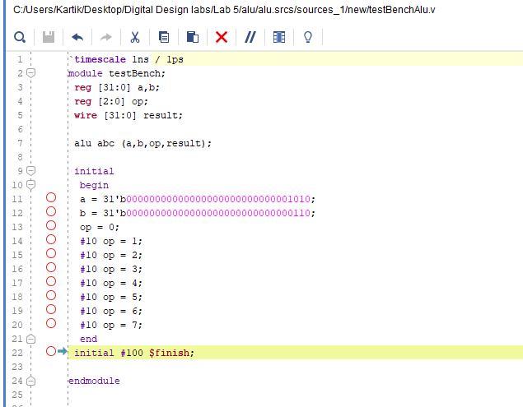

*Verilog Code*

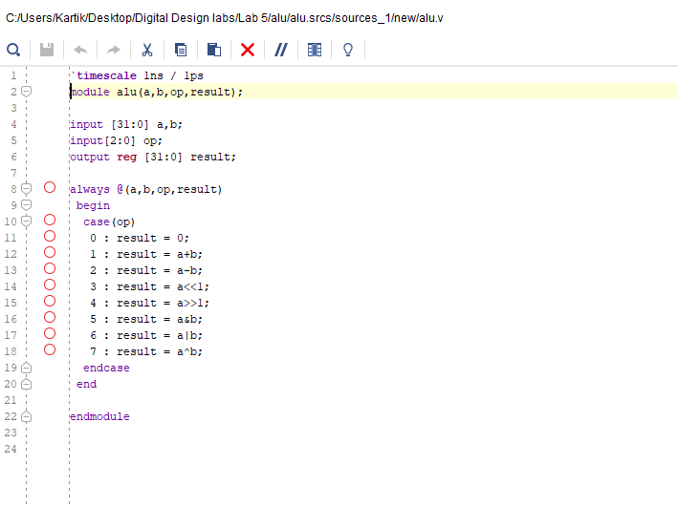

*Waveform*

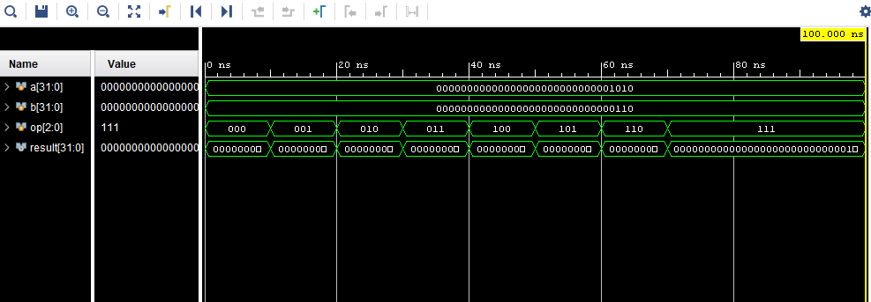

**3. Write a program to implement a 4 line to 2**

**line priority encoder using**

**a. Casex statements**

*Test Bench*

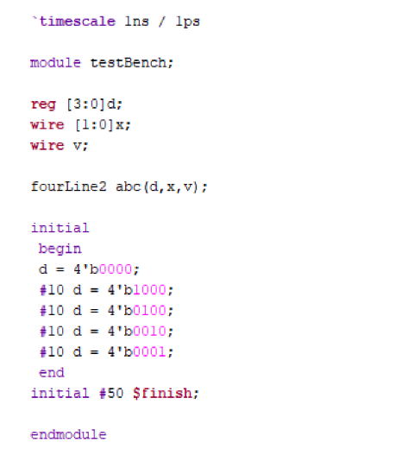

*Verilog Code*

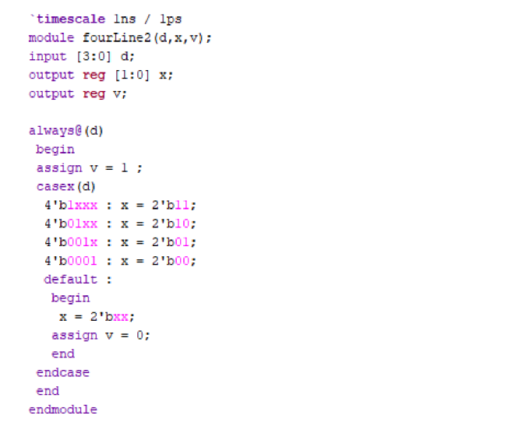

*Waveform*

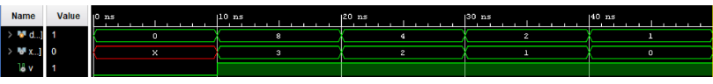

**b. For loop**

*Test Bench*

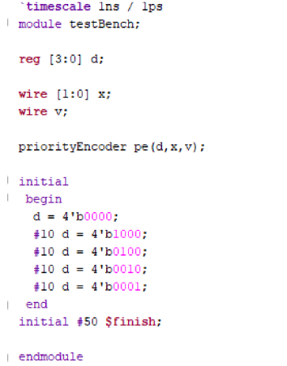

*Verilog Code*

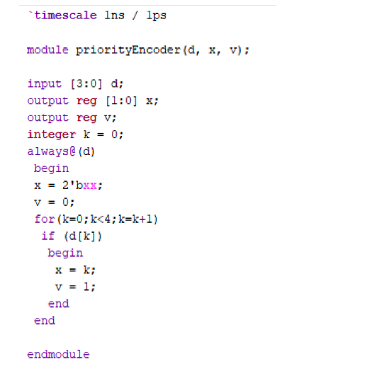

*Waveform*

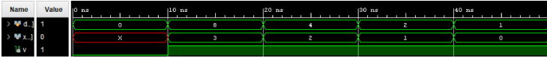

**4. Write a behavioural code for implementing**

**a. a BCD Adder/Subtractor Unit.**

**b. Multiply by 5 circuit.**

**BCD ADDER**

*Test bench*

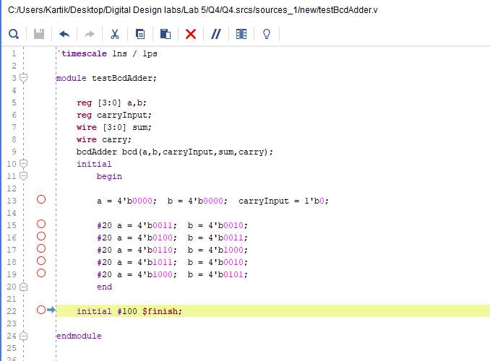

*Verilog code*

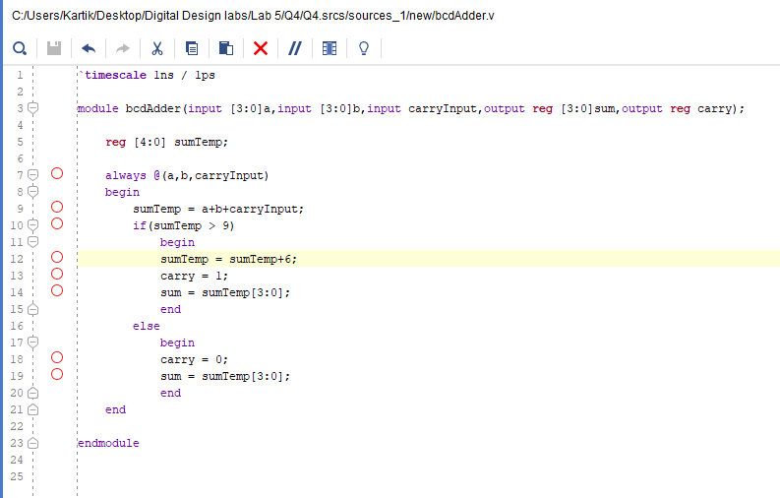

*Waveform*

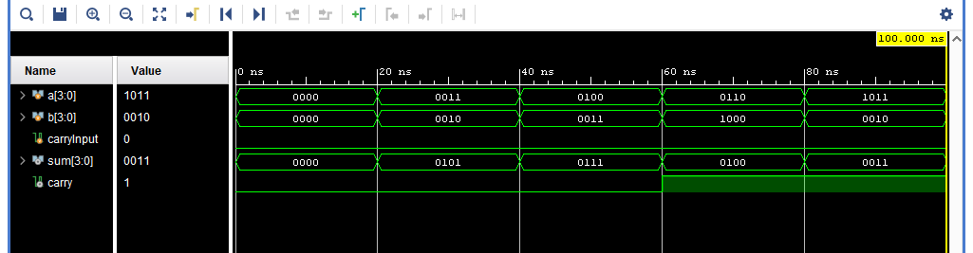

**BCD Subtractor**

*Test bench*

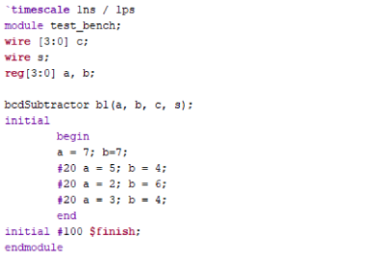

*Verilog code*

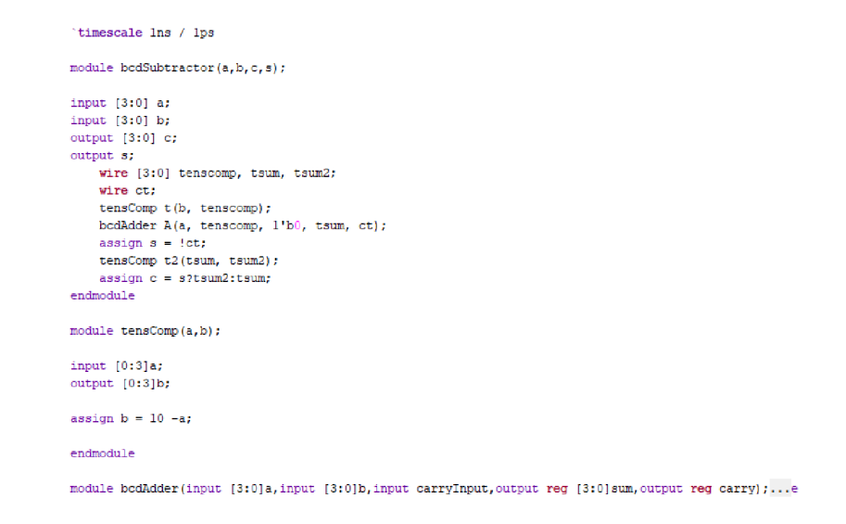

*Waveform*

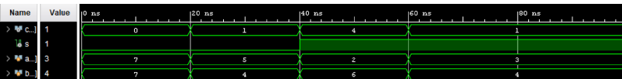

**Multiply by 5 circuit.**

*Test bench*

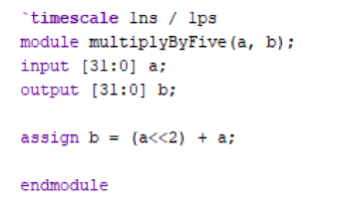

*Verilog code*

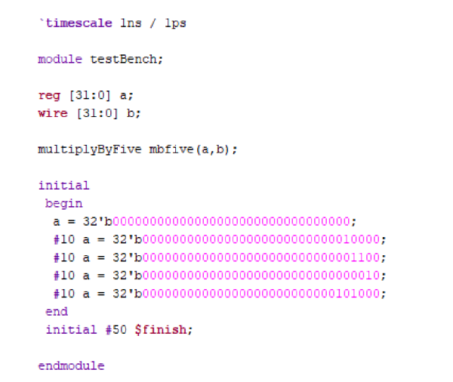

*Waveform*

**